**Response for Assignment 4.2**

Below screenshot shows the output of the Program with a function defined which takes list of words and returns their corresponding length in a list.

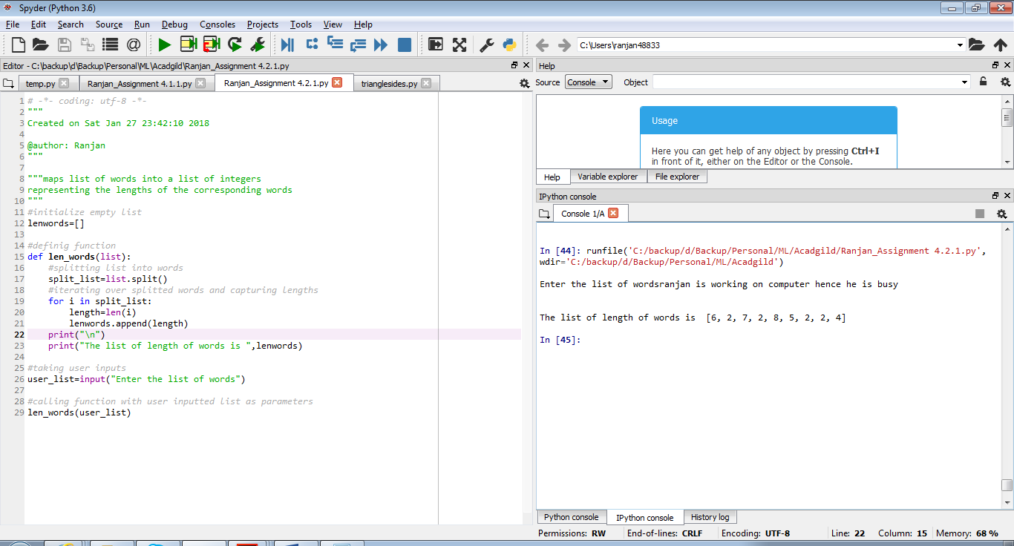

**Source Code**

#initialize empty list

lenwords=[]

#definig function

def len_words(list):

#splitting list into words

split_list=list.split()

#iterating over splitted words and capturing lengths

for i in split_list:

length=len(i)

lenwords.append(length)

print("\n")

print("The list of length of words is ",lenwords)

#taking user inputs

user_list=input("Enter the list of words")

#calling function with user inputted list as parameters

len_words(user_list)

**Problem Statement # 2**

Below is the screenshot of program which has a function which takes a character (i.e. a string of length 1) and returns True if it is a vowel, False otherwise

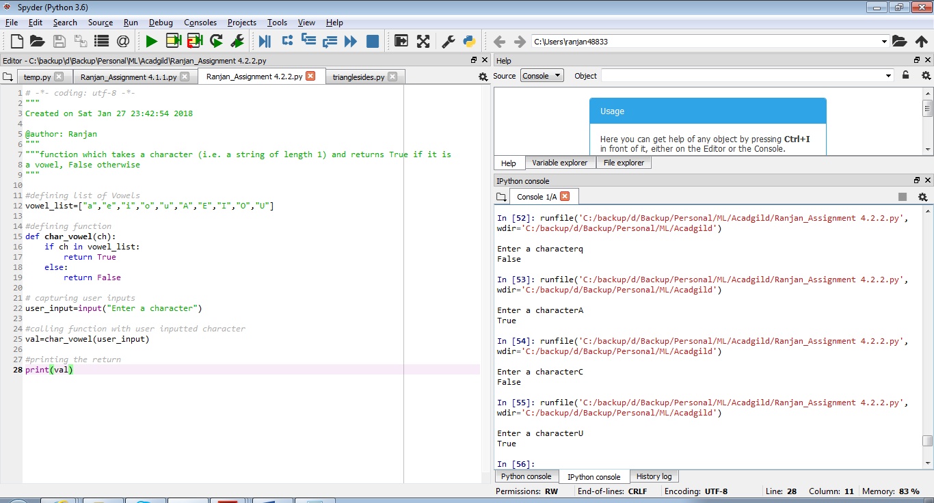

**Source Code**

#defining list of Vowels

vowel_list=["a","e","i","o","u","A","E","I","O","U"]

#defining function

def char_vowel(ch):

if ch in vowel_list:

return True

else:

return False

# capturing user inputs

user_input=input("Enter a character")

#calling function with user inputted character

val=char_vowel(user_input)

#printing the return

print(val)